# Activity – 1 TEAM BUILDING

## Break the Ice with The Four Quadrants Activity

The Four Quadrants is a tried and true team building activity to break the ice with a group or team.

It is EASY to prep for and set up. It can be MODIFIED to work with any group and/or topic (just change the questions). It is FUN, COLORFUL and works every time!

## Goal

To break the ice with a group or team.

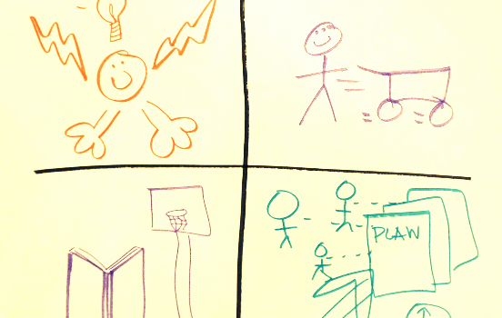

## Materials

* Flipchart and markers for each participant

## Instructions

The **steps to facilitate** The Four Quadrants activity:

1. Give each participant a piece of flip chart paper and some markers.
2. Ask them to divide their flip charts into four quadrants.
3. Ask them to DRAW (not write) their response to four questions (one for each quadrant).
4. Give them about 5-10 minutes to work individually.
5. Then, regroup and give each person 4-10 minutes (depending on your time frame) to share their chart and responses with the group.

Here are the **questions**Cheryle used with our group:

1. *What do I bring to the group?*
2. *What do I need from the group?*
3. *What is your hobby?*
4. *What is your vision for this group?*

**You can change the questions to work with any group**. For example, below are questions Michael Barrett, Resonance LLC used with a non-profit Board of Directors. He said when they shared their charts with each other some were moved to tears.

1. *What do you BRING to this organization?*
2. *What do you NEED from this team?*
3. *What LEGACY do you want to help create through this organization?*
4. *What is one event that FUNDAMENTALLY shaped your life?*

I used the questions below with a team that was working on improving how they communicated to each other when under stress. It was remarkable how much they opened up and learned about each other even though many had worked together for years.

1. *A current challenge I am facing outside of work…*
2. *The types of things that stress me the most at work…*
3. *What I need you to understand about me when I am under stress…*
4. *What I need you to do when I am under stress…*

Other questions you could insert:

* *Defining moment (personal or professional)*
* *Moment of pride (personal or professional)*
* *Worst fear (for the group, personally or professional)*
* *Desired outcome for this day/session/series of meetings*
* *Greatest challenge for this group*
* *Greatest success for this group*

This activity is so wonderful because you can write any four questions that you think will work for your group. Or have fun with it and let them come up with their own questions. Just think about what you want your group to know about each other.

What four questions will you use to get your next group engaged and sharing with one another? Please share your ideas by commenting on this method below.

#### Tips for running this activity online

* Pick an [online whiteboard tool](https://www.sessionlab.com/blog/online-tools-for-workshops/#online-whiteboard-tools) that allows to use a large, zoomable canvas (e.g. Mural or Miro)
* Users can either draw their quadrant on paper and upload an image into the board, or draw it digitally
* In the reflection step, invite users to navigate to the quadrant of the person speaking
* If you don’t have an online whiteboard tool, you can use Slack or Google docs to share and comment on the created images
* If using video conferencing software alone, invite the participants to share their screen and show their digital image, or hold up their physical drawing for the group to see
* If you want to add a fun extra dimension, encourage people to sketch quickly and if using digital tools, allow no deleting or erasers. Bad drawings can be fun to try and decode as a team.

## Background

I learned this from an amazing Master Certified Facilitator, Cheryle Maurer of Performance Consulting LLC. She facilitated our MasterMind group through this process and we all loved it and learned new things about each other.

# Activity 2 - Team Understanding

## 3 Question Mingle

Ask questions

An activity to support a group to get to know each other through a set of questions that they create themselves. The activity gets participants moving around and meeting each other one-on-one. It’s useful in the early stages of team development and/or for groups to reconnect with each other after a period of time apart.

## Goal

Support a group to get to know each other through a set of questions that they create themselves

## Materials

* Pens/Pencils
* Post it

## Instructions

#### Step 1:

Each participant writes down three questions, each on one post-it. These *questions should be open questions that you would be curious to ask other members of the group to better get to know them.*Give participants a few examples, such as: What skill would you most like to develop? Who in your life do you really look up to? When was the hardest you’ve ever laughed? Encourage participants to be thoughtful, curious and creative with their questions.

#### Step 2:

Mingle. Once all participants have written questions, they begin to mingle. Participants meet one-on-one, for one minute per meeting, and ask each other one of the questions they are holding. After asking a question and listening to the answer, they hand over that question. Thus, in each one-on-one meeting, participants will swap one question each.

#### Step 3:

Continue the mingle for a fixed amount of time and encourage participants to try to meet every other member of the group. If time allows, continue until everyone meets everyone.

#### Step 4:

After the mingle, have participants put all the post-its up on a flip-chart or the wall so that all the questions are visible. Invite participants to look at the questions and to use them as inspiration for continued conversations throughout the day and beyond.

## Background

Source: [Hyper Island toolbox](http://toolbox.hyperisland.com/3-question-mingle)

Hyper Island designs learning experiences that challenge companies and individuals to grow and stay competitive in an increasingly digitized world. With clients such as Google, adidas and IKEA, Hyper Island has been listed by CNN as one of the most innovative schools in the world

# Activity 3 - Leadership

## Leadership Pizza

This leadership development activity offers a self-assessment framework for people to first identify what skills, attributes and attitudes they find important for effective leadership, and then assess their own development and initiate goal setting.

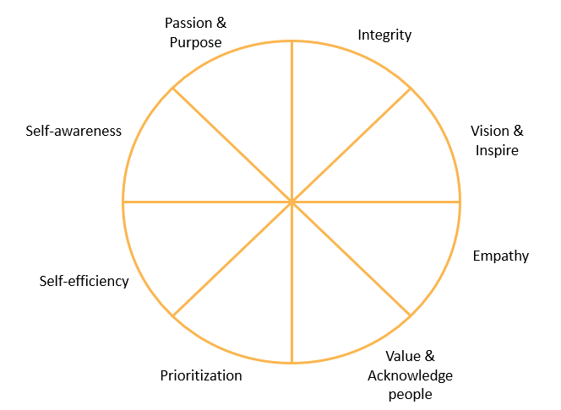

## Instructions

Don't we all like pizza? Besides the good taste, this time the slices offer a leadership self-assessment opportunity.

This exercise can help people to reflect on the different dimensions of what skills and attitudes they need in order to be a good leader.

# Activity 4 -Team Canvas Session

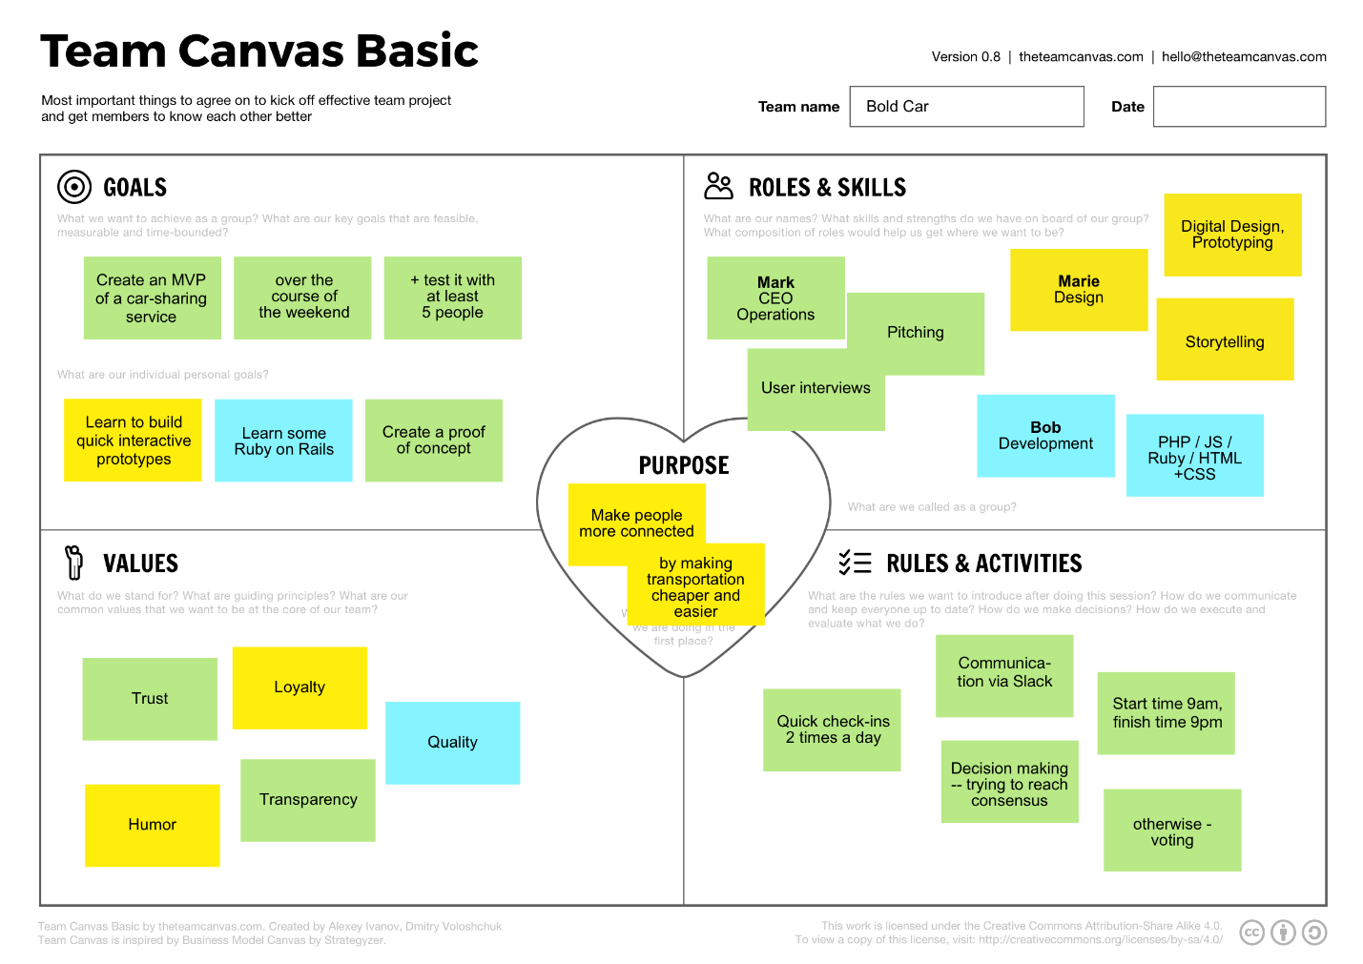

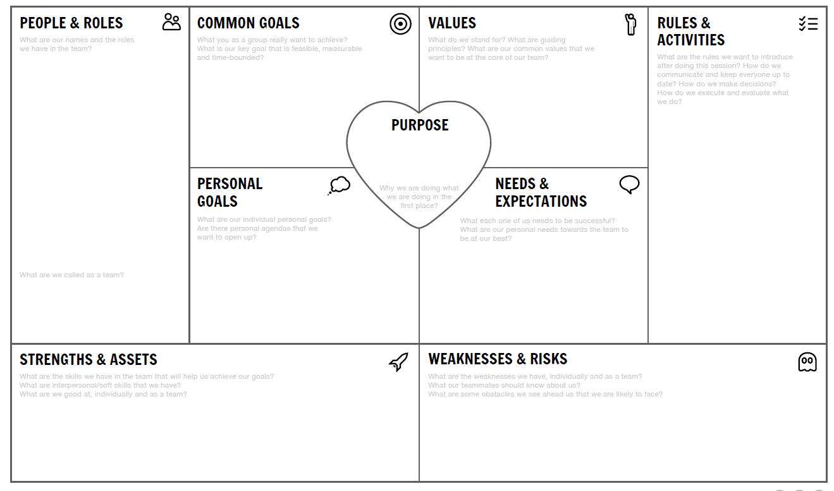

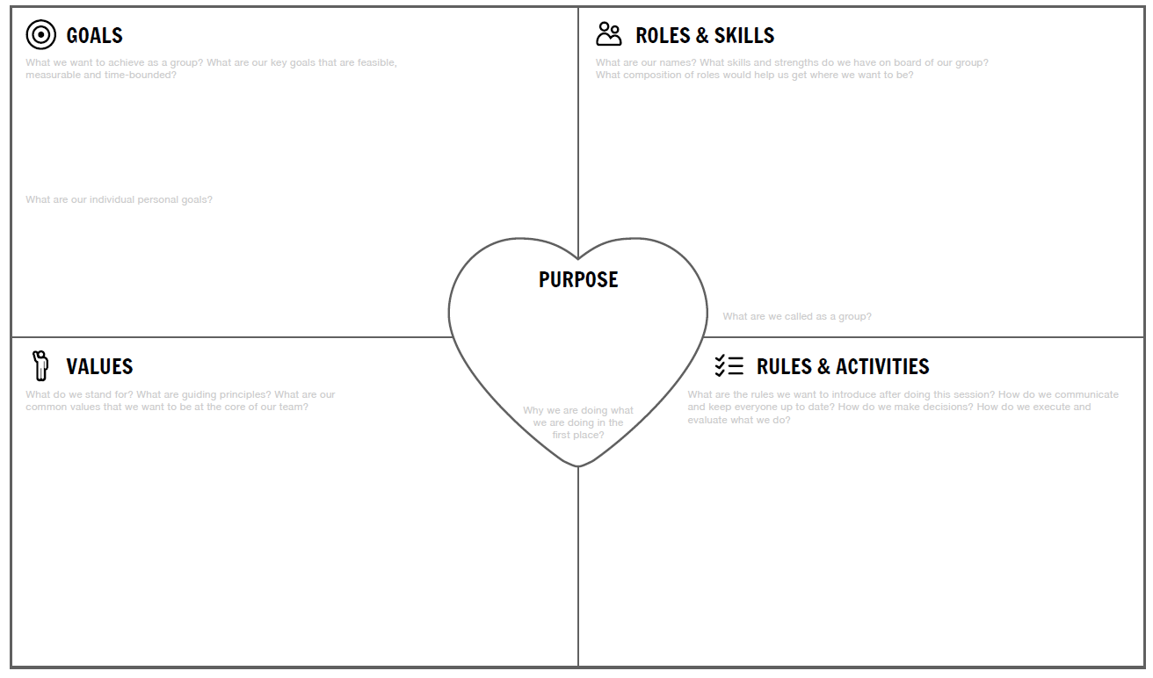

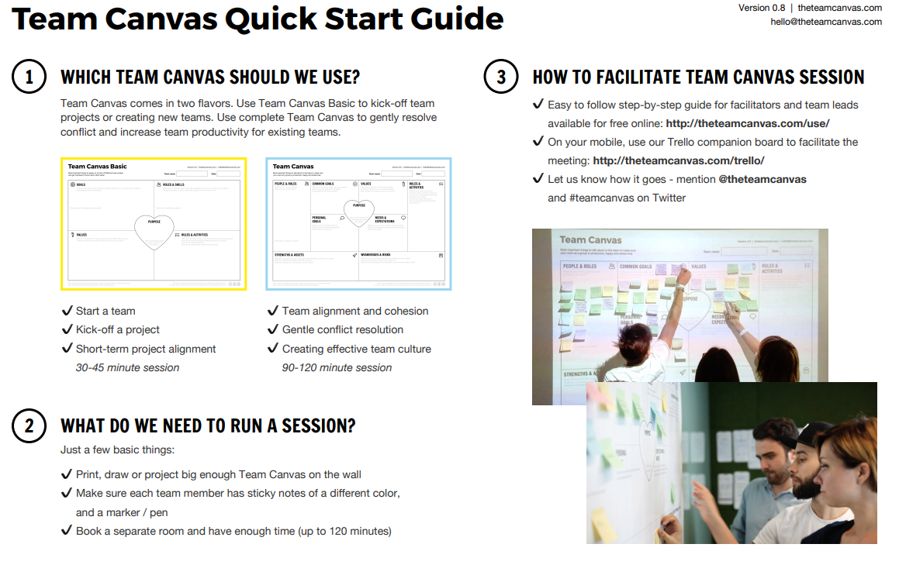

#### Flow:

1. You start the exercise by presenting the model of the Leadership Pizza: It is a reflection and self-assessment tool where you think about the most important skills and attitudes that you need to master in order to be a great leader.
2. You may present your own version of the leadership pizza to demonstrate an example.  Emphasise that your version is just an example, and they should think about what is important for leadership in their own perspective.
3. Assign time for participants to prepare their own set of important leadership skills and attributes, and ask them to draw a pizza shape and label the slices with the items they listed.
4. At this point, you may ask people to share their drawings with the group and explain which labels have they chosen. You may discuss certain decisions and identify common patterns in the group's perception of a good leader.
5. Ask participants to assess themselves on a scale of 1 to 10 for each slice. (10 is the edge if the slice, 1 is the core of the pizza). This self-assessment should serve as a baseline for setting up their own personal goals for leadership development. The areas where they find them weaker should receive more focus in their future development.

You may use this tool in coaching and mentoring sessions, too.

Encourage people to set a follow-up action within a few months of time to revisit their Leadership Pizza. They should re-assess themselves, celebrate their development and refine their next goals.

#### Variations:

* Instead of asking participants to create their own Leadership Pizza, you present a ready-made framework that shows the leadership dimensions you want people to reflect on and conduct their self-assessment. This option offers an easy way of comparing self-assessment results between people. (While the original version has the benefit for every individual to express their own priorities in leadership.)

#### Examples:

Example dimensions for a Leadership Pizza (as illustrated on the cover image):

* Integrity
* Vision & Inspire
* Empathy
* Value & Acknowledge People
* Passion & Purpose
* Self-awareness
* Self-efficiency
* Prioritization

#### Tips for running this activity online

* Pick an[online whiteboard tool](https://www.sessionlab.com/blog/online-tools-for-workshops/#online-whiteboard-tools) that allows to use a large, zoomable canvas (e.g. Mural or Miro).
* Users can either draw their leadership pizza on paper and upload an image into the whiteboard or draw it digitally.
* In the reflection step, invite users to navigate to the image of the person speaking in the whiteboard.
* If you don’t have an online whiteboard tool, you can use Slack or Google docs to share and comment on the created images.
* If using video conferencing software alone, invite the participants to share their screen and show their digital image, or hold up their physical drawing for the group to see.

## Background

I've first experienced this framework as a participant on a trainer meetup, in the form of 'Trainers' Pizza', where the same technique was centred on the question: How to be a good trainer?

# **Team Canvas Session**

The Team Canvas is Business Model Canvas for teamwork. It is an effective technique to facilitate getting teams aligned about their goals, values and purposes, and help team members find their role on the team.

## Goal

Team Canvas is a strategic framework that helps bring team members on the same page. It is made to align teams, increase cohesion and performance and to create productive team culture, fast. Team Canvas works across multiple touchpoints:

* creating a team;
* clarifying goals and addressing overall team performance (e.g. when you feel stuck as a team, or when you need to get a lot of stuff done);
* growing and onboarding new team members;
* general alignment sessions (recommended every 2-3 months).

## Materials

* Team Canvas recreated on a whiteboard, or on a big enough piece of paper (e.g. flipchart paper or A0/A1)
* Blocks of sticky notes, one for each participant, different colors
* Sharpies or pens

## Instructions

**Download Team Canvas template and mobile-friendly How To at**[**http://theteamcanvas.com**](http://theteamcanvas.com/)

#### Running the session

Introduce the team canvas as a tool to align the team members and get better at understanding goals, roles and values of your team.

Go through each step with the team, making sure you ask the questions for each segment. Encourage people to write their answers on stickies and talk about them with the team. There are fields that all team should agree on: 1. People and Roles; 2. Goals; 4. Purpose; 5. Values; 9. Rules and culture. The rest of the fields can be filled individually, with no particular need to be agreed upon.

1. People & Roles [5 minutes]

Ask people to put their names on stickies, as well as their roles. If a person has multiple roles, use separate post-its.

Questions:

* What are our names?
* What are the roles we have in the team?
* How are we called as a team?

Examples:

* Max: CEO; Marie: Design & Programming
* Name of the team: BoldCar

#### 2. Common goals [10 minutes]

Ask the team to agree on common goals.

Questions:

* What you as a group really want to achieve? What is our key goal that is feasible, measurable and time-bounded?

Examples:

* Become the leading car sharing company in our region by 2017.
* Create a 100M company in the area of Internet of Things by fall 2016.

#### 3. Personal goals [5 minutes]

Ask the team members about the individual goals they have for the project.

Questions:

* What are our individual personal goals for this project?
* Are there personal agendas that we want to open up?

Examples:

* Become more confident at iOS development [Marie]

#### 4. Purpose [10 minutes]

Ask the team to go one step beyond their common goal, and ask them why they do what they do.

Questions:

* Why are we doing what we are doing in the first place?
* What is something more important, which makes us pursue our common goal?
* Examples:
* Create a positive impact on people's lives through social innovation
* Make people’s life easier and stress-free through internet of things innovation

#### 5. Values [10 minutes]

Ask the team what are the core values - the most important principles - that they want to share within the team. The team should agree on values, so everyone accepts the final set.

Questions:

* What do we stand for?
* What are guiding principles?
* What are the common values that we want to be at the core of our team?

Examples:

* Trust
* Creativity
* Quality
* Transparency
* Mutual understanding
* Equality
* Respect

#### 6. Strengths & Assets [15 minutes]

Ask the team to share the key pieces of skills (both hard skills and soft skills) and assets available within the team. Don't dismiss ‘insignificant’ stuff. You might find that the team has capacity for martial arts, running marathons or persuading people. Encourage people to share something about themselves, as well as note important qualities they see in their teammates.

Questions:

* What are the skills we have in the team that will help us to achieve our goals?
* What are interpersonal/soft skills that we have?
* What are we good at, individually and as a team?

Examples:

* Coding (iOS/Python/etc.)
* Design
* Being devoted and driven
* Being visionary
* Energy
* Sales & pitching

#### 7. Weaknesses & Development Areas [15 minutes]

Ask the team to share the key weaknesses and areas for improvement that they see in themselves, as well as obstacles they face as a team. Make an accent on reporting what people can find in themselves, rather than discussing other’s weaknesses.

Questions:

* What are the weaknesses we have, individually and as a team?
* What our teammates should know about us?
* What are some obstacles we see ahead us that we are likely to face?

Examples:

* Easily distracted [Marie]
* Can be arrogant [Max]
* Lack of structured communication [general], etc.

#### 8. Needs & Expectations [10 minutes]

Ask the team to express the needs they have in order to be successful. Think of this as a follow up to previous two sections: once team members expressed their strengths and weaknesses, they should be able to express the needs they have to amplify strengths and be at their best despite the weaknesses.

Questions:

* What does each member of the team need to be successful?
* How could the team help each member with their needs?

Examples:

* Some «me time»
* More clear weekly status updates
* Help and coaching
* Trust
* Fun
* Stability

#### 9. Rules & Activities [10 minutes]

Ask the team to agree on common rules and activities. Think of this as of outcome of the previous sections: a concrete set of rules and activities they want to implement.

Questions:

* What are the rules we want to introduce after doing this session?
* How do we communicate and keep everyone up to date?
* How do we make decisions?
* How do we execute and evaluate what we do?

Examples:

* Keeping things within group confidential
* Weekly status updates
* Communication over Slack + Skype for calls
* Dinners together every second week (Max as organizer)
* Workday: starting from 9 to 10, meetings start at 10
* Keeping workday to 8 hours, except when it’s needed to shorten it a bit towards more

#### Wrap up [5 minutes]

As you close The Team Canvas workshop, ask the team members to tell about one single most important insight that they gained during the workshop.

#### Tips for running this activity online

* Pick an [online whiteboard tool](https://www.sessionlab.com/blog/online-tools-for-workshops/#online-whiteboard-tools) that allows to use a large, zoomable canvas.
* Set up each topic at a different area of the board, spread them out just like you would do it on a the walls of a room.
* Invite participants to zoom in and visit each section and add their ideas.
* If you’re not using an online whiteboard, we’d recommend using a collaboration tool such as Google Docs to collect the information for each step under a separate heading. Invite everyone into the same document but be very clear in regards to editing rights.
* When facilitating group discussion, we’d recommend that participants use non-verbal means to indicate they’d like to speak. You can use tools like Zoom’s nonverbal feedback tools, a reaction emoji, or just have people put their hands up.The facilitator can then invite that person to talk.

## Background

***Source:*** [Team Canvas](http://theteamcanvas.com/) - Created by  Alex Ivanov and Mitya Voloshchuk

Alex is a strategic designer, prototyper and facilitator with 8 years experience in digital and service design. Alex is IDEO alum and Hyper Island graduate. He helped to launch 50+ websites, mobile apps and ad campaigns in various teams, building hands-on knowledge of group development.

Mitya is a human capital consultant with 10 years experience in leadership development, personality assessment and team coaching. He is MBA Candidate at Berkeley Haas School of Business, specializing in organization development. Mitya helps startup teams to get from zero to flow.

# Activity 5 - Trust Card Statements

1. Don't talk too much.
2. When you discover that you have made a mistake, admit it immediately.
3. Acknowledge potential problems.
4. Share your decisions with everyone else.
5. Always speak the truth.
6. Be consistent.
7. Encourage people to discuss feelings and emotions.
8. Understand what is important to the other person.
9. Align your action and words.
10. Complete your homework on time.
11. Meet other people's expectations.
12. Listen with empathy.
13. Don't reveal confidential information to people who are not authorized to know it.
14. Don't say “Yes” unless you mean it.
15. Clean up your mess.
16. Don't gossip.
17. Respect other people's time.
18. Maintain high levels of integrity.
19. Keep your promises.
20. Volunteer to take care of other people's problems.
21. Give people the freedom to achieve the results you want.
22. Listen actively.
23. If you change your plans, be sure to inform everyone.
24. Be predictable.
25. Be prompt in replying to other people's messages.
26. Respect everyone.
27. Don't make cynical statements.
28. Explain the reasons behind your decisions.
29. Meet your deadlines.
30. Do not flatter people.
31. Handle conflicts using a problem-solving approach.
32. Apologize when you hurt someone even when it is unintentional
33. Don't misquote other people.
34. Give credit where it is due.
35. Pay attention to details.
36. Don't hide the truth even if it is unpleasant.
37. Announce your expectations in specific terms.
38. Do not talk negatively about people behind their back.
39. Disclose all relevant information.
40. Be clear about your agreements.